GSC Newsletter – March 2021 Edition

Spring provides us with an opportunity to embrace new beginnings and explore the changes in nature. This is also a great time to welcome new volunteers and make sure that they are fully onboarded and ready to go when you that extra pair of hands for a day camp or a muddy trek through forest trails. To make sure that your volunteers have a smooth onboarding process, we have prepared some tips to help you support your Scouters going through the screening process.

PRC Renewals
It is very important to stay ahead of the game and make sure that your Scouters do not go inactive while waiting for a new PRC.
Periodically you should run a Volunteer Readiness report in MyScouts to see the remaining requirements that your Scouters need to become active or stay active. This report will show you all requirements including PRC expiry dates for all of the volunteers.
You can run a Volunteer Readiness Report on volunteer requirements in MyScouts by going to Reports – Volunteer Readiness. Group Commissioners can also run the PRC VSS Expiry Listing report to focus only on those members whose PRCs will require renewal in the near future.
Returning Scouters will receive email reminders from Scouts Canada in the months leading up to their PRCs expiring that contain instructions on how to renew their PRC. If they did not receive the email they can go to http://www.backcheck.net/scoutscanada/ and follow the simple steps provided. If they are experiencing any difficulties, they can contact Backcheck directly at support@mybackcheck.com.
PRC renewals completed through Backcheck cost $20 but the results are sent directly to Scouts Canada within 48 hours of completion.

Interview
The volunteer interview is an integral component of the Scouts Canada screening process and our commitment to youth safety. It is also an opportunity to ensure the right people are being placed into the right roles. It is often one of the first steps in engagement, orientation and volunteer development which leads to a great volunteer experience and ultimately retention. It is recommended that the screening interview be one of the first steps in the screening process to help ensure the candidate is a good fit and able to comply with Scouts Canada’s standards and Code of Conduct.
The Scouts Canada Volunteer Screening Procedure requires a screening interview for each new volunteer as well as any Scouter who is transferring to a different group. These interviews are conducted using the screening interview guide by two interviewers who have completed the ‘Volunteer Screening: It’s Our Duty’ training through the David Huestis Learning Center. Both interviewers must be active Scouters with at least one having had experience conducting a minimum of five interviews.
Volunteers who are between the ages of 14 and 17 do require a screening interview before they can become a Scouter. The interview is conducted using the Interview Assessment Guide for Youth Aged Applicants with the applicant’s parent or guardian present, at least for the beginning. It is important that both the person under 18 and their parent or guardian understand that the young person is taking on a role of trust and responsibility. This position comes with expectations and a standard of behaviour which are detailed throughout the Code of Conduct and Wood Badge training. Additionally, being a Scouter means the young person, at times, may be alone with an adult Scouter and should feel comfortable reporting any inappropriate behaviour and be given clear guidance on how and when to do this.
Once an interview has been completed, it is recorded in MyScouts by the Group Commissioner or Group Registrar under ADMIN OPTIONS -> Screening from the left side menu. From there, select the Interviews tab and select ADD INTERVIEW and enter the required information.
The primary goals of the applicant screening interview are:
- To identify if the applicant should move to the next stage of the enrolment process (i.e. reference checks and criminal record checks)
- To cultivate and prepare applicants to understand their role as a good and effective leader
- To assess the risk of the applicant’s involvement including risk for sexual abuse
- Determine if the role will be a fit with the applicant’s interest and skillset

For more information, visit: https://help.scouts.ca/hc/en-ca/articles/360021105471-Interviews-FAQ

References: The Five ‘W’s’

WHO should my character references be?
- A co-worker or workplace supervisor
- If the individual has volunteered with another youth-serving organization, a person from the organization. Where the applicant has volunteered with another organization and has not provided a reference from that organization, the file is referred to the Safe Scouting Department
- Others who can attest to the person’s character
- At least two references who have known the applicant for the past five years
- More character references, when a workplace or youth-serving organization reference cannot be provided
They must be able to reply to an email in English or French. They must, therefore, have an email address.
Reminder: We require 3-character references and request a total of 5. The first 3 to respond are used.

WHAT are we asking references?
The questions asked in the reference request sent by Backcheck are not multiple choice or simply boxes to tick off. References are asked to describe their relationship with the potential volunteer, their views on the potential volunteer’s ability and skill sets needed to work with youth and other volunteers and lastly a general recommendation.

WHEN does the Group Commissioner need to be involved in reference checks?
The Group Commissioner should step in specifically when a potential volunteer transfers from another Group or a Rover transfers Crews. In this circumstance we ask the GC to complete the reference check manually. Here is the GUIDE for Group Commissioners to complete references (and also interviews) for Scouters and Rovers coming from another Group.
The other circumstance where the GC may need to step in is in extenuating circumstances for new Scouters, for example if there are persistent issues with references being processed through Backcheck. These are a case-by-case basis and the GC will be contacted by their Relationship Manager or Membership Services when this is needed.

WHERE do we ask for references?
New volunteers are asked for references within the application to become a volunteer.

WHY do we use Backcheck as our primary reference check provider?
Backcheck is Canada’s leading provider of background checks. Using a professional third party as our primary supplier for reference checks provides us with an efficient and standardized process to receive references for our over 20 000 volunteers that is prompted immediately when a new volunteer registers to join your Group. This saves cost, time and offers transparency.

How to support Scouters getting their WBI
All Scouts Canada Volunteers must complete Wood Badge I training appropriate for their role in order to continue volunteering in that role the following year. Section Scouters are required to complete Wood Badge I for The Canadian Path; Group Committee members must complete Wood Badge I for Group Committee; and Group Commissioners complete Wood Badge I for Group Commissioners.
There are several tools that you can use to support your Scouters in getting their Wood Badge I: the Volunteer Readiness report in MyScouts; the Learner Progress tool in the David Huestis Learning Centre; and the Scouter Development Map, also located in the DHLC.

Using the Readiness Report
To make sure that your Volunteers are ready serve in their roles, Group Commissioners should regularly run the Volunteer Readiness Report in MyScouts. The Readiness report highlights any outstanding screening requirements for your volunteers, including whether they need Wood Badge I, whether they are currently WBI compliant, and whether or not they even have the training. In the screenshot below, Scouter A would require WBI because they are not new to the role and this is their primary role, but they already have the training according to columns 10 and 10A. Scouter B doesn’t require WBI at this time (NA) because they are in their first year as a Scouter (10B – Yes).

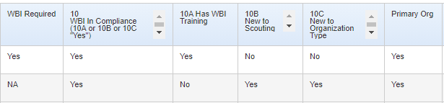

Tracking Learner Progress
The most common way for Volunteers to achieve their Wood Badge I is by completing the online training sessions. Group Commissioners can monitor their volunteers’ training progress by using the Learner Progress tool in the David Huestis Learning Centre’s Wood Badge I course.
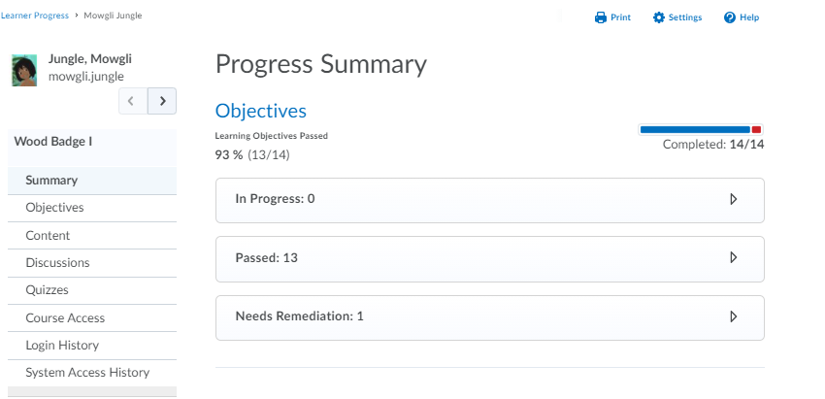

The progress summary provides a simple overview of the sessions in progress, completed, or those that need remediation. Sessions that are under the “needs remediation” sections are specific to those who use the WBI self-assessment quiz to generate a learning plan.

Using the Scouter Development Map
One of the ways for Volunteers to get started on achieving their Wood Badge I learning milestone is to begin with a self-assessment of their current skills and competencies and how they align with the Scouter Development Map competency framework. Experienced Scouters can perform the self-assessment to have their experience converted into Wood Badge I for The Canadian Path, and new Scouters can use this to generate a learning plan for them follow.
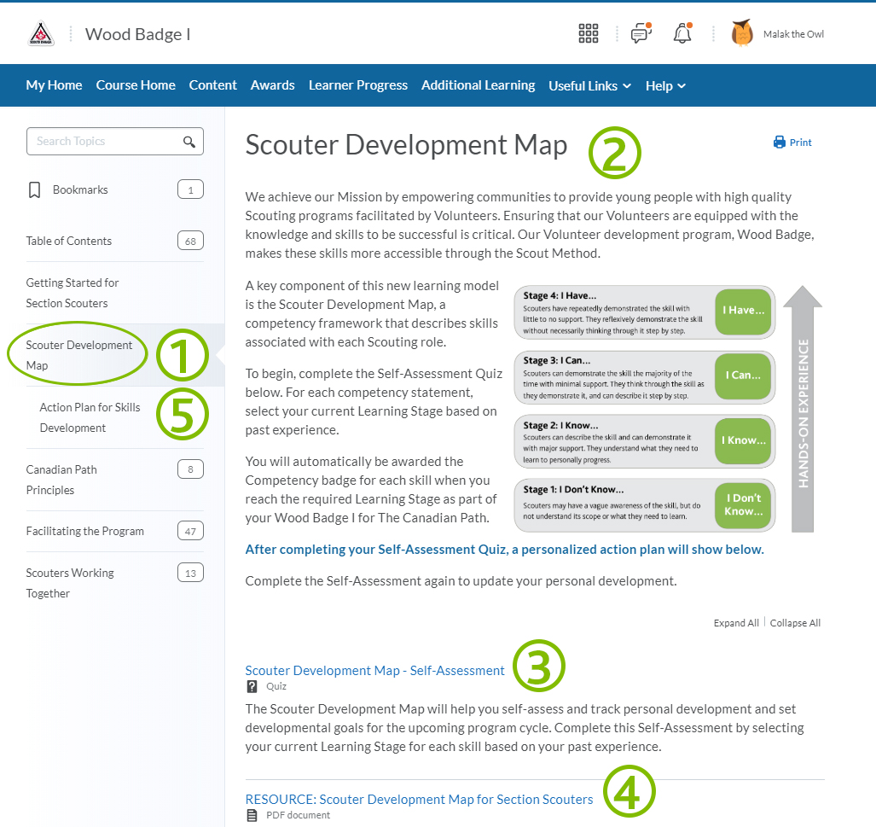

To get started:
- Click on Scouter Development Map from the Table of Contents
- Carefully read through the instructions
- Complete the Scouter Development Map – Self Assessment Quiz
- You can use the Resource: Scouter Development Map as a reference after you complete your self-assessment.
- A personalized Action Plan for Skills Development will be created for you based on your self-assessment.

Scouters for whom an action plan is generated are welcome to either complete the recommended online training sessions or work with a Wood Badge I coach/mentor to develop their skillset. Once the Scouter reaches the required level of competency, they will simply re-do the self-assessment and update their answers in accordance with their skills development.

Group Transfer Process

Transfer a Volunteer
The Scouter is required to self-register with the desired Group. Once logged into MyScouts, select the blue (Register as Volunteer) button and follow the process. The Scouter, Group Commissioner and Relationship Manager will receive a notification once completed so they can proceed with the various screening requirements.
- Once the Scouter has an ‘Active’ role with the Group, the Group Commissioner will be able to navigate to their profile and use the ‘Add a role’ option for the second section if desired.
- The GC can choose to accept the existing references, an interview will have to be completed please reference the following:
https://scoutsca.s3.amazonaws.com/2019/10/interview-guide-for-transferring-scouters-and-rover-scouts.pdf

Transfer a Participant
Groups can use "Transfer Participants" tab in on the Group profile in MyScouts to move youth between their own Sections. Please note that this only works during the same Scouting year that the registration is for.

When you can't do it yourself
Request assistance from Atlantic.membershipservices@scouts.ca, centralregistration@scouts.ca or WestRegistration@scouts.ca for transfers of participants from other Groups to your Group.
If a family approaches you, yours is the Group the youth is leaving and you are:
- Able to connect with the other Group, great! Ask the other Group request the transfer.
- Not able to connect with the other Group, suggest the parent seek help via helpcentre@scouts.ca

Be aware:
- You do not have to change your "Max Participants" numbers to move Participants between Sections in your own Group
- Space(s) vacated by the youth transferring out will become available as soon as the transfer has been completed in MyScouts. If Waitlists exist, the next person on the list will be notified of the space.

